Kitten Rescue Team Guide
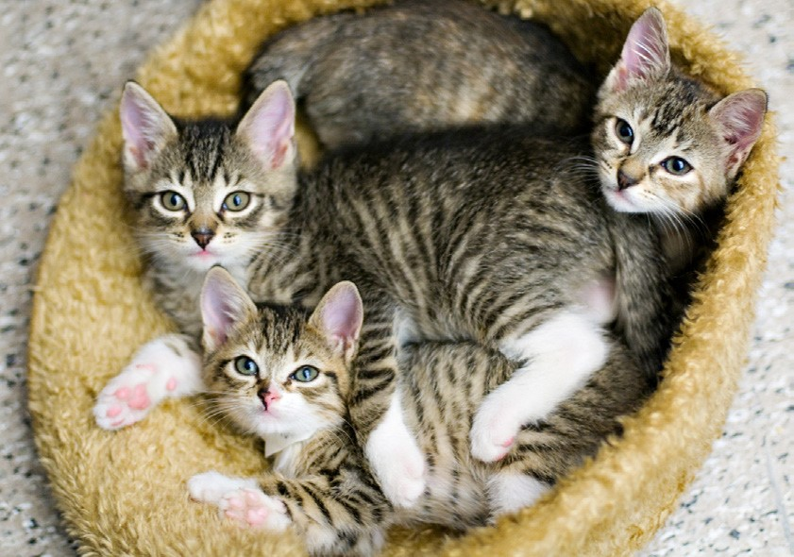
This guide has been prepared for use and instruction for Kitten Rescue Team members in caring for cats and kittens *

Contents
Overview and Requirements . . . . . . . . . . . . . . . . . . . . 4
Preparing Your Home and Family . . . . . . . . . . . . . . . 6
Getting Acquainted and Important Tips . . . . . . . . . . . 8
Kitten Growth Milestones . . . . . . . . . . . . . . . . . . . . . . .11
Daily Care for Moms with Kittens . . . . . . . . . . . . . . . .14
Daily Care for Orphaned Kittens . . . . . . . . . . . . . . . . 16
Grooming, Bathing, Socializing . . . . . . . . . . . . . . . . . . 20
Cleaning & Sanitizing . . . . . . . . . . . . . . . . . . . . . . . . . . 23
Medical Information & Concerns . . . . . . . . . . . . . . . . 26
Additional Resources . . . . . . . …… . . . . . . . . . . . . . . . 31

Is The Kitten Rescue Team Role Right for You?

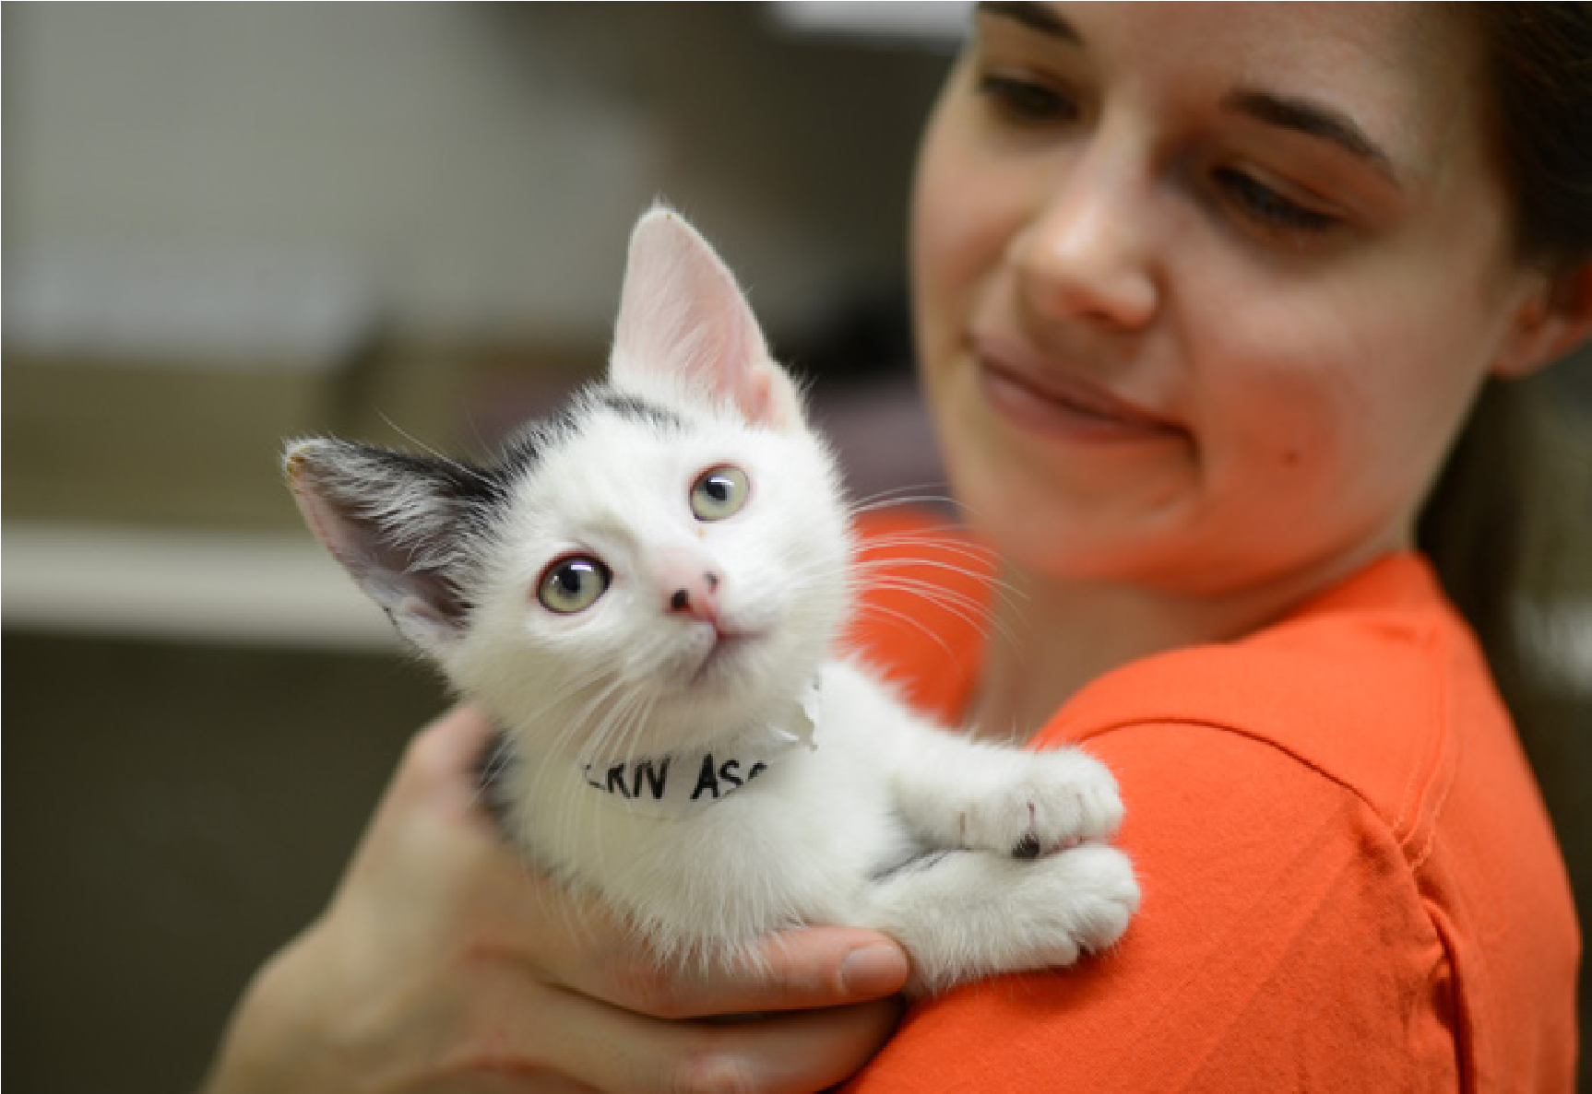

Overview

Job Title:
Kitten Rescue Team

Time commitment:
- 10-14 days per kitten/litter, around the clock as needed!

Requirements:
- Must be at least 21 years of age and be responsible and reliable. Parents can work with children as a family team
- Every family member in the household will need to be prepared for the commitment and emotions involved with socializing kittens
- Complete a Kitten Rescue Team application and agreement form
- Complete a Foster Care Application & Agreement Form on the Loudoun County Animal Services website at the following link: https://www.loudoun.gov/documentcenter/view/424
- Ensure that animals can be kept and are allowed in your home
- Must have transportation for all emergency and non-emergency treatment of kittens
- Must have a room to where you can isolate and quarantine kittens for 10-14 days to prevent disease spread

Guidelines:
- All other animals in house must be cat friendly
- Take on the responsibility for routine care in your home during the care period
- Kittens must never leave your house until the designated, Coalition-approved partner rescue organization or shelter takes them from you
- Do not have kittens from different source locations in your house at the same time
- Do not medicate kittens unless directed to do so by the Coalition-partnered rescue intake organization agreeing to take in those kittens next
- Any adoption questions or inquiries should be addressed directly with the Coalition-partnered rescue intake organization or shelter slated for intake
- Report any illness or injury immediately to the Coalition-partnered rescue intake organization or shelter

Job description/responsibilities:
- Provide temporary housing for kittens aged 8 weeks and younger. Neonatal kittens will be given to the team members trained to care for them
- Provide feedings on age appropriate timeline
- Provide medication as needed and directed by the intake rescue organization or shelter
- Kitten-proof your home to reduce potential safety hazards
- Maintain a peaceful, loving environment for the kittens and spend quality time socializing them
- Maintain communication with other Coalition members in a timely way when attempts are made to contact you
- Try to spend a minimum of two hours per day with kittens to socialize them and monitor their health. The time they spend with you is extremely important to their socialization and therefore their adoptability level

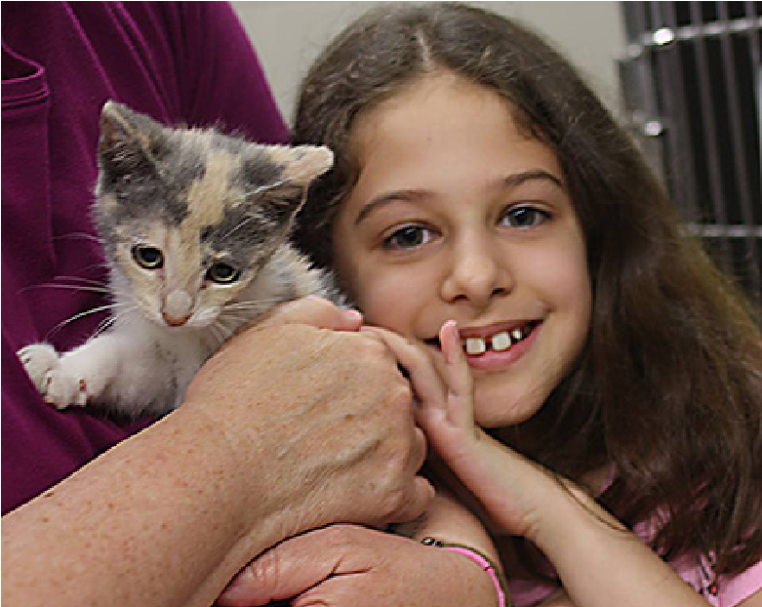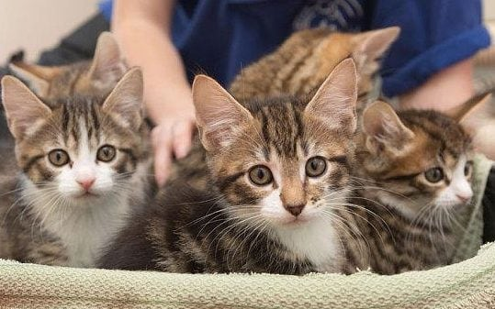

Preparing Your Home and Family

What You Should Do
- Remove small, ingestible objects from the environment; this may include small toys or parts of toys, elastic bands, paper clips, string, sewing pins and needles, ornaments, tinsel and more
- Keep toilet bowls closed, especially when very young kittens are in your care
- Secure window screens in any open windows no matter how small the opening
- Ensure that side panels on window AC units are securely in place and cannot be moved or opened
- Secure loose electrical wires, cords for window blinds and other potential hazards
- Remove plants and flowers from the vicinity of your foster animal’s space; many types of decorative vegetation are highly toxic to animals
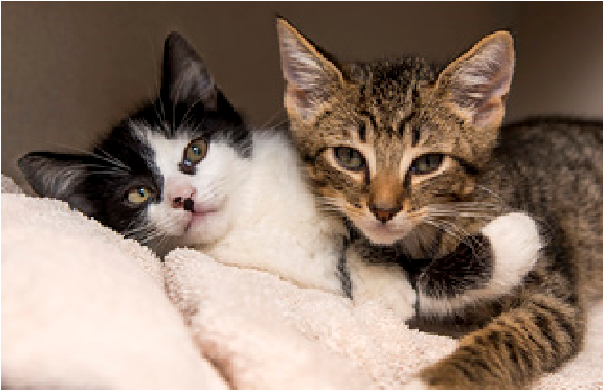
- Do not offer any human food to your kittens
- Keep your home reasonably climate controlled (if it’s too hot for you, it’s likely too hot for your kitten)
- Ensure visitors do not leave doors or windows open, and are conscientious about safety measures that are in place for your kittens
- Discard old or uneaten food and keep fresh water available at all times
- Secure/remove household toxins such as cleaning agents (including Lysol wipes), pesticides and solvents

What You Will Need (Asterisks denote bottle feeders)
- Litter box and non-clumping litter
- Large dog crate for older kittens (if applicable)
- Carrier (with door removed after transport for initial, temporary hiding spot in crate or room). For youngest kittens a top opening* carrier is ideal.
- Wet and dry kitten age appropriate food
- Formula (KMR or Breeder’s Edge), syringes (1cc, 3cc, 10cc) and bottles *
- Probiotics such as FortiFlora, high calorie supplements such as NutriCal, and electrolyte formulas such as unflavored Pedialyte *
- Heating source for neonate kittens , such as a SnuggleSafe, rice sock, water bottle, or heating pad (use caution as kittens may dehydrate) *
- Small digital scale (measures grams and ounces), a daily progress notebook *
- Scratchpads and toys (choose easy to disinfect toys or those that can be disposed of after being used by each particular litter; carpeted or wooden scratching posts should not be used)
- Bedding (towels, micro-fleece baby blankets*, cat beds) that is washable and kept clean and dry at all times – avoid cloth with loops so claws don’t get stuck
- ‘Companion’ for single kittens to simulate mom or littermate - plush toys or a Snuggle Kitty (fitted with battery operated heartbeat) *
- Flea comb (recommended)
- Food and water bowls
- Treats for older kittens
- Disinfecting products (dilute bleach or Rescue ® disinfectant wipes)
- Emergency supplies (listed later)

Kit Kittens under five weeks of age may still need an additional heating source since they cannot regulate their body temperature. You will need to provide kittens with a heating source to use in your kitten’s crate. It is very important to make sure that the kitten has an area of the crate with no additional heating where she can go if she becomes too hot.

A towel or blanket should be placed over the heat source. You may also want to cover the crate/carrier with a towel or sheet to keep the space draft-free and cozy. A kitten ‘nest’ should be within a warm, quiet room. The ambient room temperature where the kittens are located should be held around 80-85 F. Always check for signs of dehydration.

Getting Acquainted

Being in a new environment is stressful for most cats and kittens, and a normal reaction may be to withdraw or hide.
Allow your kittens some time to adjust to your home while being housed in a “safe haven” such as a roomy dog crate, pet playpen, or a separate room. For small kittens a spare bathroom may also be a good option since there aren’t many hiding spaces and they are easy to disinfect. House a cage or playpen in a quiet, calm, consistent room environment to start. If kept in a spare room, block off small areas where the kitten(s) may try to hide and get stuck.
Caging kittens for sheltering or fostering is advantageous in that caretakers can monitor eating, drinking and elimination in an ideal way. The risk of disease transmission is also greatly reduced by keeping kittens isolated in this way. Do not overcrowd the cage – larger sized litters may need to be divided into groups of 2 or 3. Make cages comfortable with bedding (3” of padding), toys and all of the necessities. The cage(s) will need to be roomy enough for food and water bowls plus a litter box. Hammocks, added spaces, and dangling toys can be amenities to include for comfort.
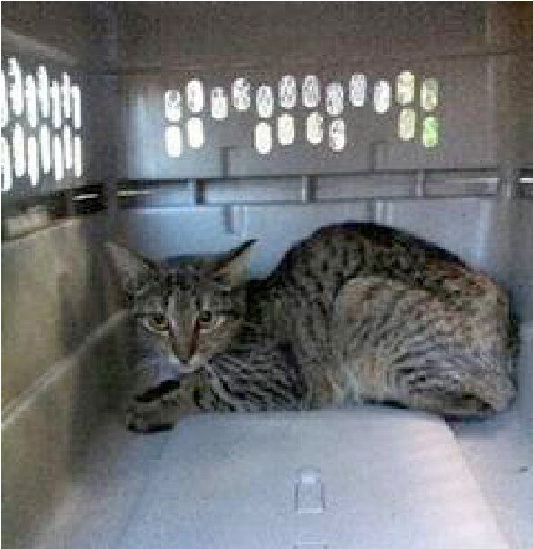
Upon arrival, you don’t necessarily need to pull your scared little guests out of hiding. Instead, you can use toys or treats to encourage them to come out. Cats and kittens need time to adjust to their new environment.
Let your kitten(s) get used to you slowly. Sit in the room and bring treats with you. Read a newspaper or a book out loud while you’re sitting there so they get to know your voice. Only offer treats in moderation.

Top Tips for Kitten Rescue Team Caregivers

Five Fundamental Needs of Kittens that need to be met

Keep kittens warm

Provide kittens with adequate nutrition

Keep kittens clean

Provide socialization

Do your best to protect them from infectious disease

Kitten proof your home

Keep mediations, cleaners, electrical cords and outlets, and house plants out of reach of the kittens

Block access to any small hiding places such as under beds or behind cabinets

Three Common Health Crises

Hypothermia/Hyperthermia (Too cold/too hot)

Hypoglycemia (Blood sugar too low)

Dehydration (Not enough water in the body)

(Early recognition of illness followed by proactive, assertive treatment can mean the difference between life and death).

Additional Tips
- Do NOT use clumping litter – especially if kittens are under 8 weeks old
- For litters of kittens that look very similar you can make identifying collars out of Ejay bands (hospital wrist bands) or masking tape bands (folded over). Bands placed on kittens must be checked regularly to ensure that they are snug but not too tight (fit one finger between the collar and the kitten’s neck), particularly as the kitten continues to grow.
- The general rule is to have 1 food bowl, 1 water bowl and 1 litter box for every 2 kittens.
- Always make sure your kittens are dry! Wet kittens can rapidly lose body temperature.
- Young kittens may try to suckle on each other. If this becomes problematic the kittens must be separated to prevent larger medical concerns
- Remember to thoroughly wash your hands after being in contact with your foster animal, especially between handling resident animals and foster animals.
- Track your foster pet’s progress on the health monitoring sheet found later in this booklet.
- Appetite and energy are the two most important things to keep watch on. A lack of interest in food or a drop in energy can indicate a serious medical issue, even if no other symptoms are present.
- Daily weight gain is crucial for growing kittens. Weigh your kittens daily to ensure adequate weight gain. Kittens should gain about ½ ounce per day or 4 ounces per week. Early diagnosis of medical issues depends on accurate daily recordings of weight!!!
- If your kitten seems sick, check immediately for dehydration by pulling up the skin of the scruff. The skin should be taut and snap back down in 2 seconds or less. If it stands up or takes some time to go back down, the kitten is likely dehydrated and may need fluids.
- Do not allow animals to be in “common rooms” until fully vaccinated, tested for FIV, FeLV, a negative fecal test and 10-14 day quarantine.
- Do not take the kitten to your own veterinarian. If the kitten requires any veterinary care, contact the associated partner rescue intake organization.
- Have the designated veterinary clinic name and phone number in conspicuous location within the house.
- Keep a simple emergency kit at hand. You can keep items in a tackle box or small crate (especially if you are out in the field in addition to fostering).

Simple Emergency Kit Contents
- Warming device
- Lactated Ringers (“fluids” bag), syringes, and needles
- Water, oral syringes
- Karo Syrup or Dextrose 50%, Q-tips
- Formula, bottle, nipples
- Toilet paper or specialized wipes (white)
- Disposable gloves
- Canned food for older kittens

Kitten Growth Milestones
Birth | 2-4 ounces | Eyes and ears are closed  Sleeps over 90% of the time  Minimal handling
2-3 days |  | Umbilical cord falls off
4 days |  | Begins to purr
10-14 days | 8 ounces | Eyes and ears should be open  Healthy kittens will be round and warm with pink skin and will rarely cry
2-3 weeks | 12 ounces | Baby incisors erupt, can begin to eliminate without help  Will start crawling, standing and playing with littermates  Begin regular handling  Ready for deworming
4 weeks | 1 pound | Baby canine teeth erupt, beginning to walk but do not have great balance, will begin to groom themselves, able to thermo-regulate  Continue daily handling  Ready for first vaccine  Ready for gruel and may be ready for introduction of dry kitten food
6 weeks | 1.5 pounds | Baby premolars erupt  Running, playing, using the litter box, grooming themselves  Should be eating dry kitten food, supplemented with canned
8 weeks | 2 pounds | Ready for surgery and adoption

Stages of Kitten-hood

Newborn
When kittens are first born they are pink-skinned and helpless. A partial umbilical cord may be observed. Their eyes are closed and their ears are folded and deaf. They can’t stand, keep themselves warm, or eat on their own. They can’t eliminate waste on their own. They are completely dependent on mom for protection, body warmth and nutrition. They fit in the palm of the hand and weigh 3-5 ounces. Even at this age, however, they can purr and make distress calls. They spend 90 percent of their time sleeping and the other 10 percent eating.

One Week Old
Kittens start to become more aware of their surroundings. At around seven days old, a kitten’s ears may begin to unfold and their eyes start to open. At the one week to 10 day mark they should weigh 4-6 ounces, still fitting in the palm of your hand.

Two Weeks Old
Bright blue eyes (commonly) can now open completely, and they are taking their first wobbly steps and starting to crawl on their tummies. They continue to grow quite rapidly and are becoming more active. Kittens at this age start interacting more with each other, but still need mom or a caregiver for food and waste elimination. They still have no teeth present. They still spend most of their time eating and sleeping. Their ears will be almost fully uncurled. At this two week mark they will weigh 6-8 ounces.

Three Weeks Old
Kittens are now playing with their siblings and becoming more mobile. By the third week you can readily determine gender. Their teeth are visible in the mouth. They are now walking more steadily. They weigh 8-12 ounces. You can introduce a litter box and start feeding them wet food
Four Weeks Old
Kittens are becoming more adept at moving about and playing with each other, toys, and people. With leaps and silly antics, they are now playing more and sleeping less. They are looking like fluffy, miniature versions of their future adult form. They should be starting to use the litter box and capable of eating solid food. Their eyesight should be nearly fully developed. With growing interest and awareness of the environment around them, it’s time for these kittens to be actively socialized by their human caretakers!

Five Weeks Old
At five weeks they will be full of energy and playing vigorously. Socialization efforts should already be underway. They should be running around silly then falling asleep right where they plop down from exhaustion. Even though they are eating solid food they should still be nursing with mom or through bottle feeding a few times each day.

Six Weeks Old
Kittens should be using the litter box and eating solid cat food. Caregivers should continue to give active play time and start training kittens to not bite or scratch hands. These kittens should be introduced to more stimulation and new experiences, including introduction to new people. At this age they should weigh anywhere from 1 to 1 ½ pounds. At around this age eyes may no longer be blue.

Seven Weeks Old
Kittens are now almost fully weaned and fairly self-sufficient. They should be allowed to explore more locations in the house and interact with other pets. It is a good idea to invite friends over to play with them.

Eight Weeks Old
If 2 pounds in weight, kittens are now ready for spay or neuter surgery. These little ones are growing up fast and are fully weaned. They should be very adept at play and learning much about the world around them. It is at this age that fosters should be starting the process of finding adopters to give the kittens permanent homes in the coming weeks.

Daily Care for Moms with Kittens
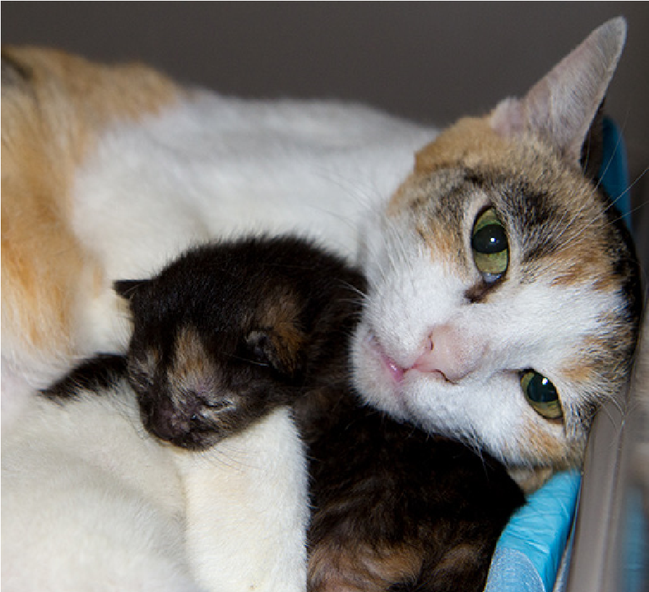
Most mothers, even first-timers, can take care of themselves and their offspring quite well. For the most part, you will leave mom and babies alone while observing for any signs of trouble.
Provide a nesting box for nursing mothers so babies can’t get out but mom can when she needs some peace and quiet. Only half of the nesting box should have extra warmth added. Bedding material should not have loops – kittens cannot retract their claws and they may become stuck.

Young Kitten Care
A kitten’s survival depends on getting consistent nutrition and warmth. The mother’s colostrum, which is the first milk produced, is vitally important to a newborn’s cardiovascular system and defense against disease. Colostrum is rich in antibodies to help protect against various infections, but kittens can only absorb these antibodies and benefit from them for a short period after birth.
So-called “Fading Kitten Syndrome,” when a newborn fades and dies despite adequate care, is usually due to either a genetic defect or lack of sufficient colostrum. For this reason, it is very important that newborns nurse as soon as possible after birth. If they do not find a nipple on their own, put their mouth close to one and hold them until they nurse.
Continued healthy nursing behavior is crucial for kitten survival. In order to tell if the kittens are nursing, put on exam gloves and gently pick up each kitten and feel for a round belly full of milk. A flat or concave belly indicates that the kitten may not be nursing. You should perform this check once or twice a day, always wearing your exam gloves.
Also, visually confirm that each kitten is actually latching onto mom. A gram scale works great to log each kitten’s weight on your health monitoring sheet (found later in this guide). Healthy kittens should gain a little weight each day.

Problem Signs
During the first two weeks, kittens should spend approximately 90% of the time eating and sleeping. If kittens are crying during or after eating, they are usually becoming ill or are not getting adequate milk. A newborn kitten is very susceptible to infections and can die within 24 hours. If excessive crying occurs, the mother and entire litter should be examined by a veterinarian, so please call us immediately.

Supplemental Feeding for Nursing Kittens with Mom
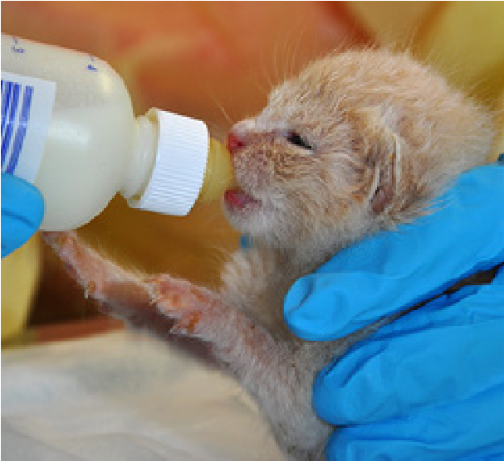
When adequate nursing isn’t possible, supplemental feeding one to three times per day may be recommended, especially for any litter with more than five kittens. You will need a supply of liquid or powdered Kitten Milk Replacer (KMR) for supplemental feeding.
The temperature of the milk replacer can be tested on your forearm and should be about the same as one’s skin. The KMR can gives directions concerning feeding amounts.
If the kittens are still nursing from their mother, the amounts recommended will be excessive. Generally, one-third to half of the listed amount should be the daily goal. Supplemental feeding may be continued until the kittens are old enough to eat kitten food.
Do Do not hold kittens on their backs like human babies or squeeze the bottle while feeding – this can cause kittens to aspirate the milk, choke and/or catch pneumonia.

If the mother does not produce milk or her milk becomes infected, the kittens will cry excessively. If this occurs, the entire litter could die within 24 to 48 hours. Total replacement feeding, using the KMR, or adopting the kittens to another nursing mother, is usually necessary.
If replacement feeding is elected, the amounts of milk listed on the KMR container should be fed. Kittens less than two weeks of age should be fed every 3 to 4 hours. Kittens 2 to 4 weeks old do well with feedings every 4 to 6 hours. Don’t feel like you have to wake them up to feed—if they’re full enough to sleep peacefully, let them rest until they wake up hungry.

Daily Care for Orphaned Kittens
Please note that young kittens are extremely fragile, and some may die no matter how well you take care of them (sometimes 1 out of 4 in the first week alone). Remain attentive to your foster kittens and provide them with the best possible care; as difficult as it is to lose a foster pet, you should not blame yourself. In the unfortunate event that your foster kitten passes away, contact the partner rescue intake organization as soon as possible.

Daily Care for Newborns Using a Bottle (0-3 weeks old)
Young kittens need to be fed every 2-4 hours throughout the day and night. Sometimes bottle feeding can be challenging, and if your kitten will not take the milk replacer from the bottle you may wait until the next feeding to try again. However, if your kitten has not eaten in two consecutive feedings, please contact the rescue intake organization.
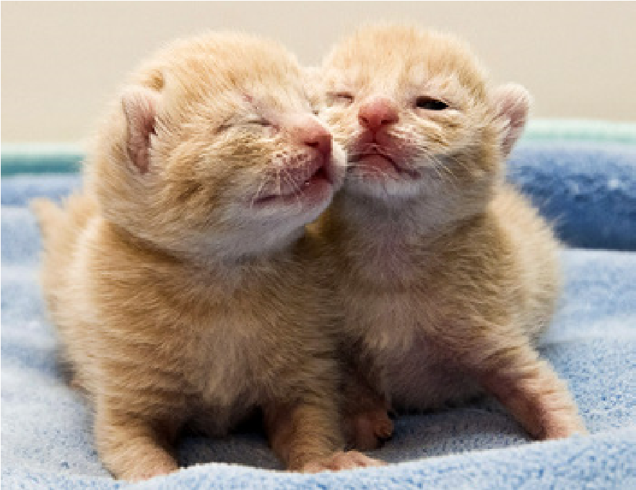
Kitten Milk Replacer (KMR) formula will be needed for all kittens requiring bottle feeding. Please follow the directions provided with the KMR to mix the formula (one part formula to two parts water). Note: Canned, pre-made KMR requires no mixing. Allow bubbles to dissipate. For the first couple of feedings, you may increase the amount of water slightly to dilute the formula and help reduce digestive upset. If stool consistency is too soft the formula may be too rich – add water. Ideally, stool should have the consistency of tooth paste. Be watchful for stool consistency as continuous diarrhea may lead to dehydration.
Mixed formula that has not been warmed can be saved in the refrigerator for up to 24 hours. The unmixed powder formula should also be kept in the refrigerator after being opened and may be kept for up to 3 months.

Nutritional and/or probiotic components may be also added to the formula. A good probiotic is FortiFlora. NutriCal is a vitamin/mineral-rich, high calorie supplement ideal for sick or picky eaters.

Prepare only the amount of formula your litter of kittens will need for each feeding. Kittens will usually need about 4mL per 3.5 ounces of body weight per feeding. Note: one (1) mL = one (1) cc. Neonates will need about 30mL over a 24-hour period.
Formula should be warmed by placing the bottle of cold KMR upright in a mug of hot water. Check the temperature of the formula on the inside of your wrist before feeding each kitten. The temperature should be warm to the touch but not hot. Coating the nipple with formula hides the rubber taste.
If kittens are not able to feed with a bottle syringe-feeding may be necessary. Apply contents of syringe into the side of the mouth in a slow manner.

Safe Feeding
You should also test the nipple on your bottle and make sure the formula drips out slowly. When held upside down to test the rate there should be approximately one drip every three seconds. It is very easy for kittens to aspirate (inhale fluids into the lungs). If formula comes out of the kitten’s nose, stop feeding immediately.
Do not feed the kitten any more until it has completely cleared the fluid from its lungs, usually by sneezing. If crackling or popping is heard as the kitten breathes, or if you suspect your kitten may have aspirated formula, contact us your intake rescue immediately.
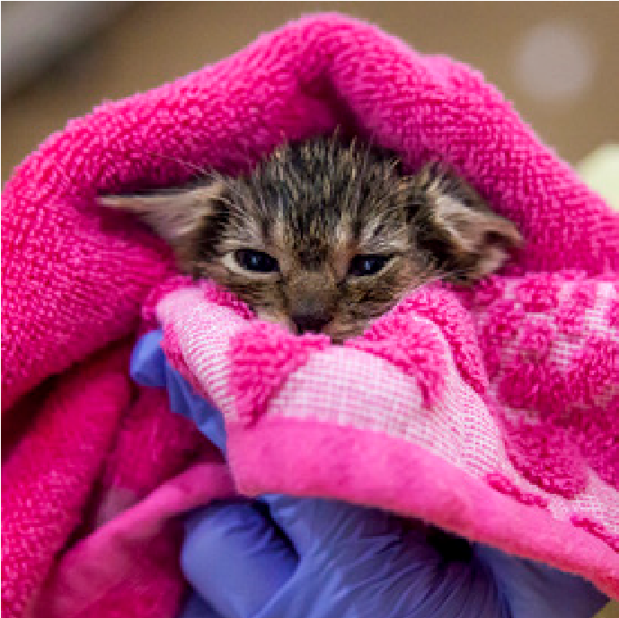
Kittens should be warm before feeding to digest food properly. Prepare kittens for feeding by placing them on their stomachs or wrapping them in a small towel like a taco if they are fussy.
If wrapped in a towel, make sure the kitten can still knead with her forelegs outside of the towel and that she is not on her back, which can cause aspiration. When placed on her stomach, make sure she is in an upright position with her head tilted slightly up and neck extended (as if she was nursing from mom).

Support the lower body with the palm of your hand and hold the head steady with your thumb and forefinger. Never force milk down by squeezing the bottle since this can cause aspiration. Bottle feeding takes practice and patience to master. A list of reasons kittens may not be eating can be found later in this manual.
Make sure you do not over-feed the kitten by checking her tummy for fullness while feeding. After bottle feeding, gently burp the kitten by placing by placing her on her stomach in the palm of one hand and patting her on the back a few times with the other hand. This will allow any air ingested to be expelled. You will not, however, hear the kitten “burp”.
Age (weeks) | Weight | Amt. (Each Feeding) | Frequency
1 | 4 oz. | 4.5 cc/ 0.16oz | Every 2 hours
2 | 7 oz. | 8 cc/ 0.27oz | Every 3-4 hours
3 | 10 oz. | 11 cc/ 0.37oz | Every 4-5 hours
4 | 13 oz. | 18 cc/ 0.6oz | Every 4-5 hours
5 | 1 pound | 24 cc/ 0.84oz | Every 5-6 hours
6+ | (Begin feeding solids) | variable | AM and PM

Clean out your bottle with soap and water between feedings.
After the kitten has finished feeding, you must now stimulate the kitten to urinate and defecate. Kittens should defecate at least once a day and should urinate every time.

Elimination
If you are fostering orphaned kittens, or mom is unable to care for her babies, it is necessary to stimulate kittens less than 3 weeks of age to urinate and defecate. The voiding reflex is normally initiated by the mother licking the kitten’s anogenital region. Kittens will start using the litter box around 3 weeks of age.
The foster caregiver must therefore imitate this by gently massaging the kitten’s anogenital area with a warm damp cloth or cotton ball. This should be done after each feeding, and each kitten should pass urine and have a bowel movement at least once a day. It may take 24-48 hours to initially regulate. Using soft, dry, white material will allow you to make note of any abnormal stool colorations. Make note of abnormal stool colors and consistencies. Small, hard dry stools usually indicate dehydration. The very first stool (meconium) will be different than subsequent occasions since it will be comprised of materials ingested in the uterus. Note urine color, dark urine may indicate dehydration.
Daily Care for Kittens Transitioning to Wet Food

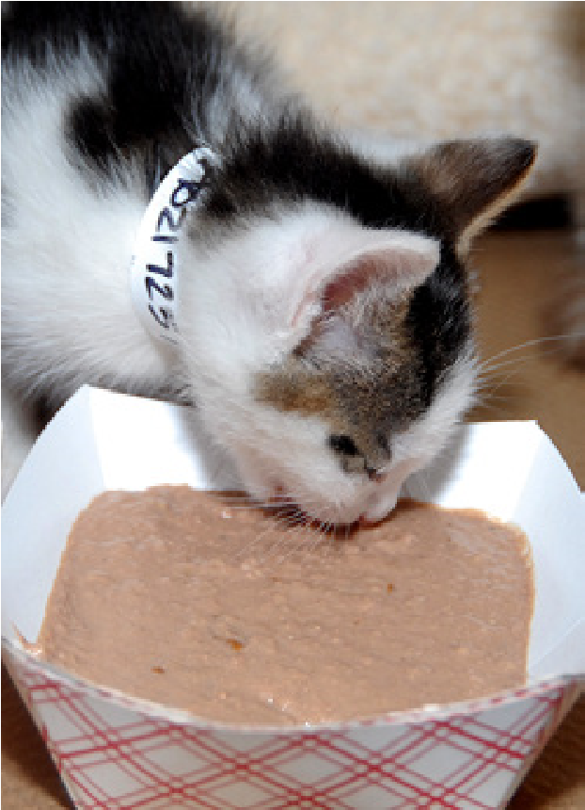
(3-5 weeks)
Transitioning kittens should be fed “gruel,” which is a pudding-like consistency mix of KMR or water and wet kitten food. They should be fed every 4-6 hours and supplemental bottle feeding may be necessary if they are not taking to the canned food. You are welcome to experiment with different consistencies but the gruel should be gradually thickened to get them ready for solid food. Leftover gruel should be discarded immediately if not eaten. Canned food that has not been made into gruel yet can be covered and refrigerated for up to 48 hours.
Once kittens have teeth, they could start to chew the nipple on a bottle, which can be very dangerous due to small pieces being ingested. This must be monitored closely.
Fresh water should be provided at all times for transitioning kittens.
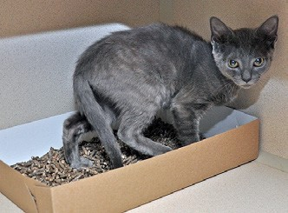
To encourage a kitten to eat the gruel, place a small amount on your finger and place it on the kitten’s tongue or lips. The goal is that she will eat on her own from a plate or bowl. This transition period can take days to weeks. A variety of wet kitten food is good to feed your kitten, but avoid fish & seafood flavors.
At this age, stimulating should no longer be necessary and she will begin urinating and defecating on her own. Continue until you notice urine and feces in the housing area.
Small litter boxes should be provided at this stage with non-clumping litter. Kittens will eventually learn how to use a litter box on their own but accidents are common for the first few weeks. If they defecate outside, move the feces to the litter box. You can also place kittens inside their litter box after meals.

Daily Care for Kittens Eating on their Own (5-8+ weeks)
Kittens who are eating completely on their own will need to be fed wet food about three times throughout the day. They should always have dry food and water available.
Don’t forget to clean their litter box at least once day (and focus on and enjoy this socialization period!).

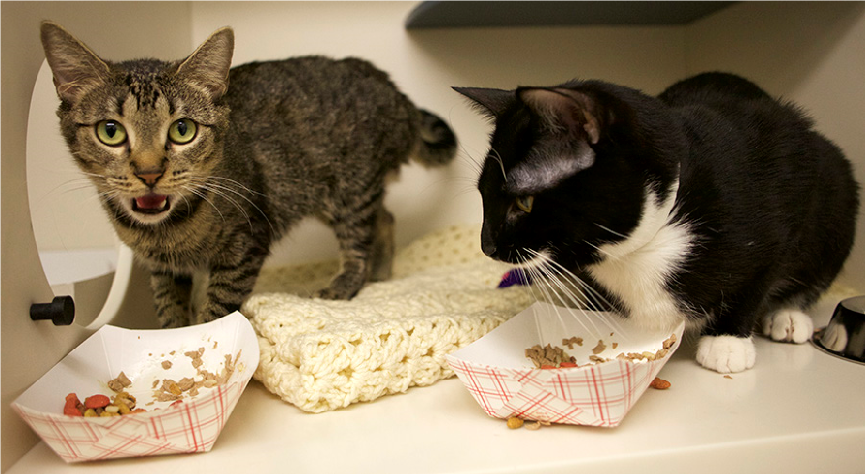

Grooming, Bathing, Socializing

Grooming & Bathing
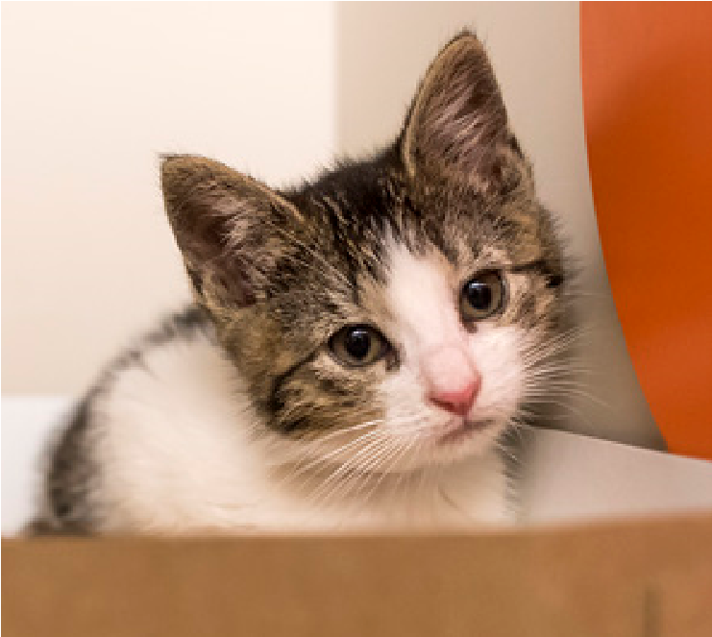
Kittens should be kept clean and will often need bathing since they are so messy. Less is more for bathing kittens.
Try to spot clean by only rinsing the kitten with warm water where he is dirty, such as his bottom. Make sure to not get a lot of water on his head, especially the eyes, nose and ears. If there is food stuck on his face, use a warm damp cloth.
Kittens cannot be put back into their home until they are completely dry. You can use a blow dryer on the lowest setting after towel drying.

Socializing Your Foster Kitten
Socialization is critical for young kittens, and they will need multiple short socialization sessions on a daily basis, as well as playtime and enrichment to help them learn to enjoy being around people.
Please follow these steps for socializing foster kittens:
- Keep the kittens confined to a dog crate in a quiet room for the first few days to make sure they are eating well & adjusting to the new environment. Offer them their carrier without its door or a cardboard box inside the crate and cover the crate with a sheet so they feel more secure.
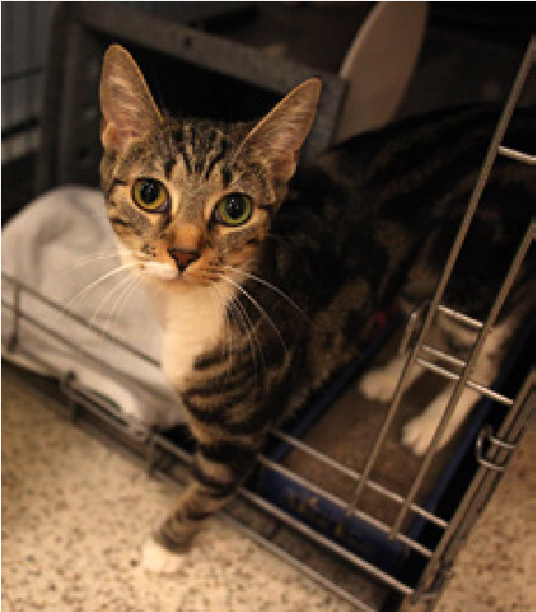
- The crate should be in a secure, cat-proof room where kittens cannot run away and hide once you start letting them out of the crate.
- Once they are eating well and comfortable, and after the initial 14-day quarantine, allow them to explore this cat-proofed area when supervised; keep them confined when not supervised.
- Make sure to use every meal time as a socialization event. Offer kittens food and sit with them while they eat. Eventually work toward putting the food on your finger and having them eat it from there. Once they are comfortable with this, slowly bring the food closer to you so that they have to climb on your lap to get the food. Progress to petting them while they eat, starting with their face and shoulders. Eventually work on handling more and more and then finally, picking up.
- Short socialization sessions (3-5 minutes) several times a day are better than one or two long sessions.
- Once the kittens become social with you, have friends or family interact with them too, so that they learn to be social with everyone
- Work on getting them used to household noises and voices by slowly introducing them (i.e. talking in a normal voice, laughing, opening cabinets, etc.)
- Always pair food or playtime with your presence, whether or not you are touching or interacting with them.
- Give them safe objects to explore, such as cardboard boxes.
- Do not allow them to play with your hands or feet. This will encourage play biting which will continue and be painful once they get older.
- Practice restraint positions and typical handling approaches that will be used in veterinary settings. To make it easier for future adopters to trim claws themselves, make kittens used to their paws being handled. Practice grooming technique to get them used to brushing.
- Set limits to roughness with littermates.
- Keep track of favorite toys for each kitten. Try to buy toys that can be cleaned easily.

Using Food for Successful Kitten Socialization
Kittens younger than 8 weeks can usually be socialized without much difficulty, while older kittens who have had no positive interaction with humans can take much longer. However, the guidelines below can help you successfully socialize kittens – and often shy adult cats as well!
Keep in mind that while these techniques are usually successful, there is always the chance that cats might not respond as well or as quickly as you hope, so you may need a contingency plan in place.
Before you start working with kittens, make sure you're on their level so you can comfortably interact without looming over them or backing them into corners. A medium to large sized bathroom or any small room without hiding spots will be a good space to work within.
Food: The Great Motivator
Food is the most important tool to facilitate the socialization process. Growing kittens have an insatiable appetite – and that fact works in your favor because it spurs them to approach and be touched. So don't put food down and walk away – make kittens interact with you to get that reward. If the kittens are healthy, using the litter box, and will eat in front of you, you can safely begin delaying meals just enough to give you the advantage of hunger.
If the kittens will eat in your presence, progressively pull the dish as close to you as possible. Stay with the kittens until they have finished eating and then take any remaining food away with you when you leave. (Always leave water, of course.)
When the kittens have progressed to eating right beside you (with your hand touching the dish), start offering something tasty off your finger. Gerber or Beech-Nut baby foods are favorites in turkey, chicken or beef flavors (with no rice, vegetables, onion powder or garlic powder).
You can also let the kittens learn to lick from a spoon, popsicle stick, or tongue depressor if at first they want to chew your finger instead of lick it
Body Contact
Initiate contact at the beginning of a session when the kittens are particularly hungry.
Start with them eating from a dish or off the finger and eventually progress to touching and petting while they are in your lap eating. Start petting in the head and shoulder area only. If the kittens run off, lure them back with baby food on the finger. You can also put a dish in your lap and let an entire litter climb on you to get it!
Expand petting and touching around the head and shoulders by touching the underbelly. Also try nudging them from one side to the other while they are engrossed in eating. Just having your hands near them and gently pushing them around is an important preparation to being picked up.
Picking Up
Set up two dishes and gently lift/scoot a kitten the short distance from one dish to the other, very close to the ground. If the kitten is engrossed in eating she won't mind being lifted if it goes smoothly and quickly. If not, lure her back and start over.
Sit on the same level as the kittens so the first real lift is close to the floor. Have a full jar of baby food opened and ready ahead of time. Lift under the chest with a small dish of food directly in front of the kitten's nose the entire time. Hold the kitten loosely on your knees and eventually up to your chest so your heartbeat can be heard.
Once that's mastered, try lifting while you're kneeling and then eventually while you're standing.
When the kitten is very full and getting sleepy, try gentle petting and work up to holding and petting without the incentive of food being present. If this works you should be able to try it at other times between meals.
Most feral kittens are frightened by interactive play when first exposed to humans. Start with a toy that isn't too threatening and allows distance – a toy on the end of a stick, for example. Be flexible and experiment – and then use whatever proves to be the kitten's favorite thing as a reward for new steps or to break through a plateau.
Before putting them in a cage in an adoption center or at an adoption event, make sure they have been exposed to and responded well with a few different socializers.
Transition to Adoption
You may need to give adopters a crash course in socializing. You can also suggest that kittens be started in the bathroom or another small room with the litter box. And always let adopters know what toys the kittens are most comfortable with and enjoy most.

Cleaning & Sanitizing During and After Foster Stays
The most common disease organisms seen in foster animals are viruses, bacteria, parasites and fungi. It is very important to repeatedly and thoroughly clean and disinfect any areas of your home where your foster pets are—and any objects foster pets contact.
Daily and weekly cleanings will help keep your foster kittens and any other animals happy and healthy. A more thorough sanitation will be needed between each new foster pet that comes to your home.
Routine practices to control disease transmission include:
- Setting up an isolation area for the kittens
- Practicing good hand hygiene before and after handing animals or objects in the isolation area
- Cleaning and disinfecting items in the isolation area using the appropriate products

The Quarantine/Isolation Area
Your area should include the following components:
- Isolation from other pets in home
- Pet-proof
- Surfaces that are easy to clean and disinfect (vinyl or tile floor, not carpet)
- Stocked with supplies that are dedicated to the area and easy to sanitize
- A good source of ventilation (separate ideally)
- Low human traffic
Some foster parents will also prefer to wear a smock or other protective wear to avoid direct contact with their clothing that comes in contact with other animals.

Hand Hygiene
Hand washing is critical—it is the most important way of reducing transmission of disease between animals. Clean hands thoroughly with soap and water before and after handling animals or items in the animals’ environment.
Thorough hand washing procedure:
- Wet hands with warm (not hot) water
- Apply liquid or foam soap (1-2 pumps)
- Vigorously lather for a minimum of 15 seconds
- Rinse thoroughly
- Pat hands dry on clean towel

Cleaning and Disinfecting Products
Soaps and detergents are not the same as disinfectants. It’s important to understand how these two groups of products work and to use them appropriately.
- Soaps and detergents are cleaning agents that work by suspending dirt and grease and breaking up organic matter. Soaps do not necessarily kill germs. Dish and laundry soaps are common examples of detergents.
- Disinfectants are chemical solutions that kill germs. The particular germs killed depend on the ingredients in the disinfectant. While some disinfectants serve a dual purpose and have some cleansing properties, many disinfectants do not effectively remove dirt and grease. In general, disinfectants must be applied to already cleaned surfaces and allowed to remain in contact with the surface for a minimum period of time in order to be effective.

Choosing Detergents and Disinfectants for the Home
When making the choice of a particular product for your foster home, it is necessary to understand the active ingredients, strength, required contact time, effect against typical shelter diseases and any potential side effects.
You also will want to check on the product’s availability, since there are many products but (with the exception of standard household bleach) very few can be bought at the grocery store, are safe for felines and effective against common diseases.
For this reason, we recommend using a basic dish soap and water wash followed by thorough rinsing and then disinfecting with diluted bleach.

Using Bleach as a Disinfectant
The recommended dilution of standard, non-color safe 5.25% household bleach for most agents of disease is 1 part bleach to 32 parts water (1/2 cup bleach to 1 gallon water or 2 tablespoons to 1 quart for small batches). Bleach needs to be mixed fresh daily. The recommended contact time is 10 minutes. Bleach is then rinsed off and the surface allowed to dry.

Do Not Use
Phenol-based products are known to be toxic to cats and should not be used. If unsure about a product, a good rule of thumb is to avoid if the name contains “sol”.

Typical Sanitation Procedure for the Home
All surfaces may not be easily cleaned and disinfected in the typical foster environment, but thorough and repeated washing and vacuuming helps in decreasing the number of germs in the environment.

Surface/Object | Suggested Procedure | Special Step
All surfaces and objects | Thorough cleaning and disinfection between each animal’s stay in your home | Thoroughly clean surfaces with soap or detergent, and then apply bleach (for any surfaces that can be bleached). Bleach mixtures should be ½ cup bleach per gallon of warm water. This can be added to a spray bottle but it needs to be made fresh each day. Let sit 10 minutes, then rinse thoroughly and dry. If using bleach, be sure to let the item or area air out thoroughly before placing animals into the area again
High contact surfaces (counters, light switches and floors) | Daily cleaning with detergent and weekly disinfection with a product like bleach solution | Vacuum all rugs and furniture vigorously and frequently
Visibly soiled objects/ surfaces | Cleaning with a detergent and disinfection with a product like bleach solution
Litter boxes and food bowls | Daily cleaning and weekly disinfection with a product like bleach solution | Sanitize food bowls separately from litter boxes
All regular surfaces (any surface your foster animal comes in contact with like walls blinds, etc.) | Weekly cleaning and disinfection with products like bleach solution | Increase frequency to daily or more when infection is present
Laundry (bedding, blankets and some toys) | Remove organic material before laundering  Use detergent and bleach  Thoroughly machine dry on high heat | Take caution in moving soiled items to washing machine to prevent environmental contamination  Throw away heavily soiled items

Medical Concerns

Call the Intake Rescue Immediately in These Situations

Difficulty breathing, erratic breathing, gasping for air

Very high or low body temperature

Very pale, blue, or grey gums

Not eating or drinking

Diarrhea

Vomiting

Sneezing or coughing

Seizures or neurologic symptoms

Injury or trauma, including cuts and fractures

Unable to stand or walk

Failure to eat or drink

Signs of lethargy or uncharacteristic/abnormal behavior

Straining or unable to urinate for more than 24 hours

Failure to defecate for more than 2 days

Difficulty giving birth

If you observe any of the symptoms listed below, call the intake rescue for next steps and to coordinate a veterinary clinic visit if necessary.

Upper Respiratory Infections (URI)
Viral and bacterial respiratory infections are very common in cats, especially young or stressed ones. Symptoms include clear to colored discharge from eyes and/or nose, loss of appetite, depression, congestion, sneezing, coughing, fever, etc.
Wash your hands thoroughly after handling an animal with visible URI symptoms and before contact with any other cats as URI is extremely contagious. URI is similar to a human cold, but is generally not transmittable to people or other animal species except for cats. Any cat showing signs of an upper respiratory infection should be isolated from other cats in the household.

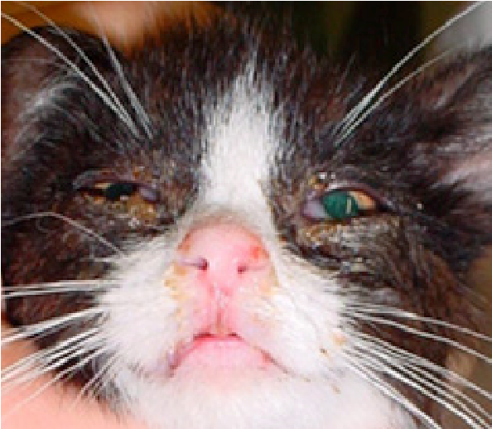
Conjunctivitis
Symptoms include clear or colored eye discharge, painful eyes, eyes that are crusted shut or swollen. Ocular antibiotics and ointments are often required. Some viral upper respiratory infections can cause corneal ulcers, which are emergencies. A painful eye should always be examined by a vet. Many causes of conjunctivitis are contagious to other cats.

Kitten Hypoglycemia
Young kittens are very susceptible to hypoglycemia (low blood sugar) and regular feeding (either by bottle or by nursing if mom is present) is vital to prevent this from happening. Most instances of hypoglycemia in the kitten are the result of inadequate nutrition; either not enough or poor quality (indigestible) food.
Excessive exercise may also cause the body to use up more sugar than is available. Some illnesses can also cause episodes of hypoglycemia. The typical symptoms of hypoglycemia include lack of energy and listlessness, weakness, wobbliness and even seizures.
If untreated, kittens are susceptible to coma, severe neurological damage, and even death. If you suspect your kitten may be hypoglycemic, offer a small amount of food and call the medical hotline immediately for further instructions.

Limping
Limping can be caused by physical injury or may be the result of a fever. Place a limping kitten in a carrier for 30 minutes to rest. If the kitten continues to limp after that time, even if it is sporadic, contact the intake rescue for further instruction.
Vomiting
Vomiting is not normal. It can be a symptom of many different medical issues.

Diarrhea
Diarrhea can be caused by a number of things (e.g. diet, stress or parasites) and can rapidly debilitate small kittens. Panleukopenia (also known as feline distemper) is a highly contagious and potentially fatal viral disease in cats and kittens that can also cause diarrhea. (See resource for complete panleukopenia information at the end of this guide.)

Internal Parasites
Foster animals are routinely treated for some internal parasites, but there are many potential parasites that may be present, and sometimes repeated treatments are required. Common parasites include but are not limited to Coccidia, Giardia, roundworms, tapeworms and hookworms.
If parasites are observed or suspected, a fresh fecal sample may be requested for evaluation at a veterinary clinic. Signs of parasites may include a large, hard belly, diarrhea, worms in vomit or the stool, tapeworm segments (similar in appearance to grains of rice) around the anus, a scruffy looking coat, and/or an inability to gain weight. Some parasites are contagious to other animals through direct or indirect contact with infected feces. Most of these parasites require medication.

Ringworm
Ringworm is a very contagious fungus that is transmittable to other species as well as people. The fungal spores can live in the environment for a long time.
Signs of ringworm can vary but typically include irregularly shaped areas of fur loss and the skin in these areas will usually have a crusty appearance. Any cat or kitten showing signs that may be the result of ringworm must be isolated from other animals in the household. Do not use bleach on a cat or kitten! Do not use Teatree oil!.

Fleas
Fleas feed on the blood of cats, dogs, humans and other animals and can transmit disease. Signs include intense itching and scratching and fur loss, particularly along the back and at base of tail. Look for flea dirt and eggs. Flea combs are helpful. One consequence of numerous flea bites is the occurrence of anemia in the kitten. Contact the intake rescue to set up a vet appointment.

Earmites
Earmites are tiny parasites that live in the ear canal. They can cause itching, scratching, head-shaking and dark brown discharge in the ears that often looks like dirt or coffee grounds. They are contagious to other cats and dogs, but usually require direct contact with the infected animal to be spread.

Panleukopenia
Panleukopenia is a viral infection that most commonly affects kittens, young cats and unvaccinated felines. Panleukopenia has a very high mortality rate, even with treatment.
Unfortunately, this illness can be frustrating to deal with because the virus can survive in the environment for years. This means that other unvaccinated cats/ kittens can become infected with panleukopenia simply by coming into contact with places where an infected cat has been. Symptoms include fever, diarrhea, lethargy, vomiting, loss of appetite and even sudden death.
The virus is highly contagious to other cats, especially through contact with infected feces or vomit but also contact with contaminated objects such as bowls, hands, clothes, etc. (See complete panleukopenia resources at the end of this guide.) 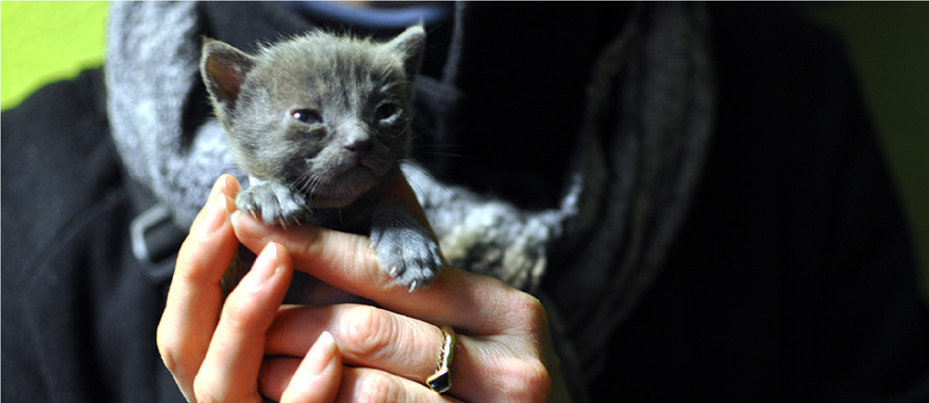

Reasons Kittens May Not Be Eating

New environment/not hungry, try again in an hour.

Not fully awake – kittens over 2 weeks old need to be fully awake when feeding (unlike younger kittens).

Bottle concept requires introduction, squeeze a tiny drop of formula onto the kittens tongue.

The kitten is dehydrated, hypothermic or hypoglycemic.

Formula is too hot or too cold.

Bad taste to formula, a new mix may be needed (fresher than 24 hours old).

Nipple opening may be the wrong size, modify as needed.

Inadequate support, feed on belly with head slightly raised/ place fingers lightly on cheeks and chin.

Unable to suckle with enough force, loosen cap slightly to allow air in to replace formula as the kitten suckles

The kitten may need to burb, defecate or urinate. Burp kittens after feeding or during breaks. Stimulate urination/defecation in an upright position with the use of soft toilet paper.

Cleft palate or other deformity missed during intake exam – the kitten will need prompt veterinary care (surgery likely).

Illness – kittens often decline rapidly without prompt diagnosis and treatment and may need syringe or tube feedings and possibly subcutaneous fluids. Isolate sick kittens.

An older kitten may be ready for solid food – offer wet food and small, dry kibble. Always offer plenty of clean water to drink.

Additional Resources

http://aspcapro.org/resource/causes-clinical-signs-transmission-feline-panleukopenia
http://aspcapro.org/resource/shelter-health-disease-management/feline-panleukopenia
ASPCA Professional www.aspcapro.org
Allie Cat Allies www.alleycat.org
Best Friends www.bestfriends.org
UC Davis Koret Shelter Medicine www.sheltermedicine.com
Cornell Feline Health Center www.vet.cornell.edu/FHC
National Kitten Coalition info@kittencoalition.org , www.KittenCoalition.org

* This guide was originally excerpted from the ASPCA’s Los Angeles Foster Care Program and modified for use by the Loudoun Community Cat Coalition through permission by the ASPCA and the ASPCApro.org resource.
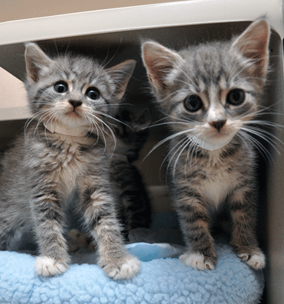

Animal Health Monitoring Sheet

Animal Name:______________________________________ Foster Parent Name: _____________________________________

Please indicate with a “Y” or “N” as appropriate in the columns.
Date | Time | C  Cough | S  Sneeze | V  Vomit | D  Diarrhea | BM  Bowel | U  Urine | APPT  Appetite | Observation Comments  Note any observations regarding bodily functions, appetite, or behavior

